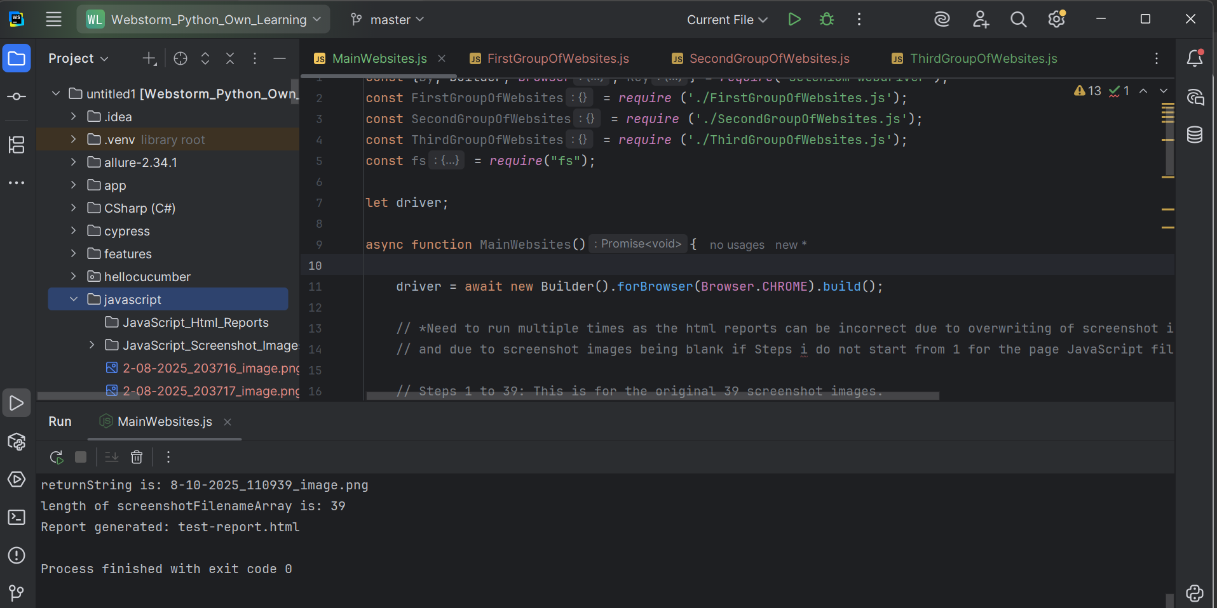

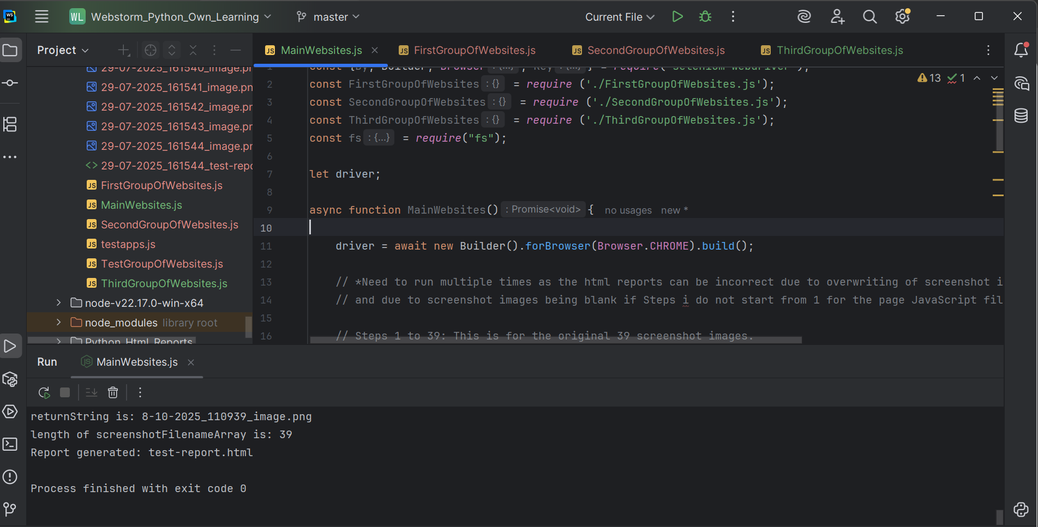

Important -
Issues with MainWebsites.js (therefore, do not use this method which does not have code errors, should run each page JavaScript file (FirstGroupOfWebsites.js, SecondGroupOfWebsites.js, and ThirdGroupOfWebsites.js) on its own with the Current File option only):
// *Need to run multiple times as the html reports can be incorrect due to overwriting of screenshot images;
// and due to screenshot images being blank if Steps i do not start from 1 for the page JavaScript files.*

const {By, Builder, Browser, Key} = require('selenium-webdriver');
const FirstGroupOfWebsites = require ('./FirstGroupOfWebsites.js');
const SecondGroupOfWebsites = require ('./SecondGroupOfWebsites.js');
const ThirdGroupOfWebsites = require ('./ThirdGroupOfWebsites.js');
const fs = require("fs");

let driver;

async function MainWebsites(){

driver = await new Builder().forBrowser(Browser.CHROME).build();

// *Need to run multiple times as the html reports can be incorrect due to overwriting of screenshot images;
// and due to screenshot images being blank if Steps i do not start from 1 for the page JavaScript files.*

// Steps 1 to 39: This is for the original 39 screenshot images.
const FirstGroupOfWebsites = new FirstGroupOfWebsites();

// Note: The step numbers i for each page JavaScript file should start from 1,
// so that the screenshot images are displayed (would not be blank) for the html reports from
// the second page JavaScript file onwards

// Steps 1 to 2: This is only for reaching the Latest tab https://aminoapps.com/c/maplestorysea/recent/ with the driver
const SecondGroupOfWebsites = new SecondGroupOfWebsites();

// Steps: 1 to 4: This is only for reaching the Home tab https://aminoapps.com/c/maplestorysea/home/ with the driver,
// then going to the Latest tab by locating the text "Latest" (there should be no whitespace characters after > and before < for Inspect)
const ThirdGroupOfWebsites = new ThirdGroupOfWebsites();

// For each page JavaScript file, only immediately after the first driver.get("..."); statement,
// let title1 = await driver.getTitle(); should be used, so that the first screenshot image of the html report would not be uncaptured
// title1's number 1 can be any number

// Using for loops to try to cause later (the second and third) page JavaScript files to run actually
// prevents the first page JavaScript file from starting due to the for loop delay

// Screenshot images for the html reports for the second page JavaScript file onwards can be incorrect

// Text which are supposed to be entered are sometimes not captured by the screenshot images

// Does nothing (the fourth html report is not generated)
// const testResults = [...FirstGroupOfWebsites, ...SecondGroupOfWebsites, ...ThirdGroupOfWebsites];

// Does nothing (the fourth html report is not generated)
// let htmlContent = '<html><body><h1>Test Report</h1>';
// testResults.forEach(result => {
// htmlContent += `<div>
// <p>Step: ${result.step}</p>
// <p>Status: ${result.status}</p>
// <img src="${result.screenshot}" alt="Screenshot" width="300">
// </div>`;
// });
// htmlContent += '</body></html>';
// fs.writeFileSync('./' + currentDateTime() + '_test-report.html', htmlContent);
// console.log('Report generated: test-report.html');
}

FirstGroupOfWebsites.js
const {By, Builder, Browser, Key} = require('selenium-webdriver');
const assert = require("assert");
const {writeFileSync} = require("node:fs");
const {write} = require("selenium-webdriver/io");
const test = require("node:test");
const fs = require('fs');
// const WebDriverIO = require("WebDriverIO");

let startIndex = 0
let endIndex = 5
let pdfMagicNumber = 'JVBER'
let imgMagicNumber = 'iVBOR'
let base64Code

(async function FirstGroupOfWebsites() {

async function takeTheScreenshot() {
let encodedString = await driver.takeScreenshot();
const now = new Date();
const formattedDateTime = `${now.getDate()}-${(now.getMonth() + 1).toString().padStart(2, '0')}-${now.getFullYear().toString().padStart(2, '0')}_${now.getHours().toString().padStart(2, '0')}${now.getMinutes().toString().padStart(2, '0')}${now.getSeconds().toString().padStart(2, '0')}`;
console.log(formattedDateTime);
let text1 = formattedDateTime;
let text2 = "_image.png";
await writeFileSync(text1.concat("", text2), encodedString, 'base64');
base64Code = encodedString.slice(startIndex, endIndex);
assert.strictEqual(base64Code, imgMagicNumber);
console.log("The takeTheScreenshot() function's returned text is: " + text1 + text2);
let returnString = text1 + text2;
console.log("returnString is: " + returnString);
return returnString;
}

function currentDateTime(){
const now = new Date();
const formattedDateTime = `${now.getDate()}-${(now.getMonth() + 1).toString().padStart(2, '0')}-${now.getFullYear().toString().padStart(2, '0')}_${now.getHours().toString().padStart(2, '0')}${now.getMinutes().toString().padStart(2, '0')}${now.getSeconds().toString().padStart(2, '0')}`;
return formattedDateTime;
}

let screenshotFilenameArray = [];

let i = 1;
let stepNameString = 'Step ' + i;
const testResults = [
//{ step: stepNameString, screenshot: screenshotFilenameArray[0], status: 'PASS' },
];

let driver;

driver = await new Builder().forBrowser(Browser.CHROME).build();

driver.get("https://demo.guru99.com/");

let title1 = await driver.getTitle();

screenshotFilenameArray.push(await takeTheScreenshot());
console.log("length of screenshotFilenameArray is: " + screenshotFilenameArray.length);
testResults.push({step: stepNameString, screenshot: screenshotFilenameArray[i-1], status: 'PASS'});
i = i + 1;
stepNameString = 'Step ' + i;

let emailInputField = await driver.findElement(By.name("emailid"));

screenshotFilenameArray.push(await takeTheScreenshot());
console.log("length of screenshotFilenameArray is: " + screenshotFilenameArray.length);
testResults.push({step: stepNameString, screenshot: screenshotFilenameArray[i-1], status: 'PASS'});
i = i + 1;
stepNameString = 'Step ' + i;

emailInputField.sendKeys("abc@gmail.com");

screenshotFilenameArray.push(await takeTheScreenshot());
console.log("length of screenshotFilenameArray is: " + screenshotFilenameArray.length);
testResults.push({step: stepNameString, screenshot: screenshotFilenameArray[i-1], status: 'PASS'});
i = i + 1;
stepNameString = 'Step ' + i;

let submitButton = driver.findElement(By.name("btnLogin"));

screenshotFilenameArray.push(await takeTheScreenshot());
console.log("length of screenshotFilenameArray is: " + screenshotFilenameArray.length);
testResults.push({step: stepNameString, screenshot: screenshotFilenameArray[i-1], status: 'PASS'});
i = i + 1;
stepNameString = 'Step ' + i;

submitButton.click();

screenshotFilenameArray.push(await takeTheScreenshot());
console.log("length of screenshotFilenameArray is: " + screenshotFilenameArray.length);
testResults.push({step: stepNameString, screenshot: screenshotFilenameArray[i-1], status: 'PASS'});
i = i + 1;
stepNameString = 'Step ' + i;

let title2 = driver.getTitle();

screenshotFilenameArray.push(await takeTheScreenshot());
console.log("length of screenshotFilenameArray is: " + screenshotFilenameArray.length);
testResults.push({step: stepNameString, screenshot: screenshotFilenameArray[i-1], status: 'PASS'});
i = i + 1;
stepNameString = 'Step ' + i;

await driver.get("https://www.bing.com");

let title3 = driver.getTitle();

if(title3 === "Search - Microsoft Bing"){
console.log("title3 Pass.");
}

screenshotFilenameArray.push(await takeTheScreenshot());
console.log("length of screenshotFilenameArray is: " + screenshotFilenameArray.length);
testResults.push({step: stepNameString, screenshot: screenshotFilenameArray[i-1], status: 'PASS'});
i = i + 1;
stepNameString = 'Step ' + i;

let microsoftBingSearchBar = driver.findElement(By.name("q"));

screenshotFilenameArray.push(await takeTheScreenshot());
console.log("length of screenshotFilenameArray is: " + screenshotFilenameArray.length);
testResults.push({step: stepNameString, screenshot: screenshotFilenameArray[i-1], status: 'PASS'});
i = i + 1;
stepNameString = 'Step ' + i;

microsoftBingSearchBar.sendKeys("MapleStorySEA Unfunded Amino");

screenshotFilenameArray.push(await takeTheScreenshot());
console.log("length of screenshotFilenameArray is: " + screenshotFilenameArray.length);
testResults.push({step: stepNameString, screenshot: screenshotFilenameArray[i-1], status: 'PASS'});
i = i + 1;
stepNameString = 'Step ' + i;

microsoftBingSearchBar.sendKeys(Key.ENTER);

for (let i=0; i<99999; i++){
console.log("Wait for the initial \"MapleStorySEA Unfunded Amino - Search\" webpage to finish loading.");
}

screenshotFilenameArray.push(await takeTheScreenshot());
console.log("length of screenshotFilenameArray is: " + screenshotFilenameArray.length);
testResults.push({step: stepNameString, screenshot: screenshotFilenameArray[i-1], status: 'PASS'});
i = i + 1;
stepNameString = 'Step ' + i;

let title4 = driver.getTitle();

//let searchTab = driver.findElement(By.id("b-scopeListItem-copilotsearch"));

//screenshotFilenameArray.push(await takeTheScreenshot());
//console.log("length of screenshotFilenameArray is: " + screenshotFilenameArray.length);
//testResults.push({step: stepNameString, screenshot: screenshotFilenameArray[i-1], status: 'PASS'});
//i = i + 1;
//stepNameString = 'Step ' + i;

//searchTab.click();

//screenshotFilenameArray.push(await takeTheScreenshot());
//console.log("length of screenshotFilenameArray is: " + screenshotFilenameArray.length);
//testResults.push({step: stepNameString, screenshot: screenshotFilenameArray[i-1], status: 'PASS'});
//i = i + 1;
//stepNameString = 'Step ' + i;

// This element keeps being stale (using a for loop does not work), so it cannot be found
//let allTab = driver.findElement(By.id("b-scopeListItem-web"));
// allTab.click();

//driver.get("https://www.bing.com/search?pglt=299&q=MapleStorySEA+Unfunded+Amino+-+Search");

screenshotFilenameArray.push(await takeTheScreenshot());
console.log("length of screenshotFilenameArray is: " + screenshotFilenameArray.length);
testResults.push({step: stepNameString, screenshot: screenshotFilenameArray[i-1], status: 'PASS'});
i = i + 1;
stepNameString = 'Step ' + i;

let title5 = driver.getTitle();

screenshotFilenameArray.push(await takeTheScreenshot());
console.log("length of screenshotFilenameArray is: " + screenshotFilenameArray.length);
testResults.push({step: stepNameString, screenshot: screenshotFilenameArray[i-1], status: 'PASS'});
i = i + 1;
stepNameString = 'Step ' + i;

let requiredSearchResultLink = driver.findElement(By.partialLinkText("Featured | [MapleStorySEA] Unfunded Tips"));

screenshotFilenameArray.push(await takeTheScreenshot());
console.log("length of screenshotFilenameArray is: " + screenshotFilenameArray.length);
testResults.push({step: stepNameString, screenshot: screenshotFilenameArray[i-1], status: 'PASS'});
i = i + 1;
stepNameString = 'Step ' + i;

for (let i = 0; i < 50; i++) {
//requiredSearchResultPartialLinkText.sendKeys(Keys.DOWN);
requiredSearchResultLink.sendKeys(Key.DOWN);
}

screenshotFilenameArray.push(await takeTheScreenshot());
console.log("length of screenshotFilenameArray is: " + screenshotFilenameArray.length);
testResults.push({step: stepNameString, screenshot: screenshotFilenameArray[i-1], status: 'PASS'});
i = i + 1;
stepNameString = 'Step ' + i;

for (let i = 0; i < 50; i++) {
//requiredSearchResultPartialLinkText.sendKeys(Keys.DOWN);
requiredSearchResultLink.sendKeys(Key.UP);
}

screenshotFilenameArray.push(await takeTheScreenshot());
console.log("length of screenshotFilenameArray is: " + screenshotFilenameArray.length);
testResults.push({step: stepNameString, screenshot: screenshotFilenameArray[i-1], status: 'PASS'});
i = i + 1;
stepNameString = 'Step ' + i;

requiredSearchResultLink.click();

screenshotFilenameArray.push(await takeTheScreenshot());
console.log("length of screenshotFilenameArray is: " + screenshotFilenameArray.length);
testResults.push({step: stepNameString, screenshot: screenshotFilenameArray[i-1], status: 'PASS'});
i = i + 1;
stepNameString = 'Step ' + i;

driver.get("https://aminoapps.com/c/maplestorysea/home/");

let title6 = driver.getTitle();

screenshotFilenameArray.push(await takeTheScreenshot());
console.log("length of screenshotFilenameArray is: " + screenshotFilenameArray.length);
testResults.push({step: stepNameString, screenshot: screenshotFilenameArray[i-1], status: 'PASS'});
i = i + 1;
stepNameString = 'Step ' + i;

let aminoSearchBar = driver.findElement(By.className("nav-search-input"));

screenshotFilenameArray.push(await takeTheScreenshot());
console.log("length of screenshotFilenameArray is: " + screenshotFilenameArray.length);
testResults.push({step: stepNameString, screenshot: screenshotFilenameArray[i-1], status: 'PASS'});
i = i + 1;
stepNameString = 'Step ' + i;

aminoSearchBar.sendKeys("MapleStorySEA Unfunded Amino");

screenshotFilenameArray.push(await takeTheScreenshot());
console.log("length of screenshotFilenameArray is: " + screenshotFilenameArray.length);
testResults.push({step: stepNameString, screenshot: screenshotFilenameArray[i-1], status: 'PASS'});
i = i + 1;
stepNameString = 'Step ' + i;

let aminoSearchTerm = "MapleStorySEA Unfunded Amino";
let aminoSearchTermLength = aminoSearchTerm.length;
for (let i = 0; i < aminoSearchTermLength; i++) {
aminoSearchBar.sendKeys(Key.BACK_SPACE);
}

screenshotFilenameArray.push(await takeTheScreenshot());
console.log("length of screenshotFilenameArray is: " + screenshotFilenameArray.length);
testResults.push({step: stepNameString, screenshot: screenshotFilenameArray[i-1], status: 'PASS'});
i = i + 1;
stepNameString = 'Step ' + i;

aminoSearchBar.sendKeys("MapleStorySEA Unfunded Amino");

screenshotFilenameArray.push(await takeTheScreenshot());
console.log("length of screenshotFilenameArray is: " + screenshotFilenameArray.length);
testResults.push({step: stepNameString, screenshot: screenshotFilenameArray[i-1], status: 'PASS'});
i = i + 1;
stepNameString = 'Step ' + i;

let threeWebElementsList = driver.findElements(By.tagName("svg"));
let aminoSearchBarMagnifyingGlassButton = threeWebElementsList[0]
// Have tried, even
// let aminoSearchBarMagnifyingGlassButton = driver.findElement(By.tagName("svg"));
// would cause an error if
// aminoSearchBarMagnifyingGlassButton.click()
// is used, despite this being the first element of the list
aminoSearchBar.sendKeys(Key.ENTER);

let popularPostsText = driver.findElement(By.tagName("h3"));
// popularPostsText is the first of the two elements for this array, if using
// let tagNameH3WebElementArray = driver.findElements(By.tagName("h3"));

screenshotFilenameArray.push(await takeTheScreenshot());
console.log("length of screenshotFilenameArray is: " + screenshotFilenameArray.length);
testResults.push({step: stepNameString, screenshot: screenshotFilenameArray[i-1], status: 'PASS'});
i = i + 1;
stepNameString = 'Step ' + i;

driver.get("https://aminoapps.com/c/maplestorysea/home/");

let title7 = driver.getTitle();

screenshotFilenameArray.push(await takeTheScreenshot());
console.log("length of screenshotFilenameArray is: " + screenshotFilenameArray.length);
testResults.push({step: stepNameString, screenshot: screenshotFilenameArray[i-1], status: 'PASS'});
i = i + 1;
stepNameString = 'Step ' + i;

let privacyNoticeAcceptButton = driver.findElement(By.className("confirm-close"));

screenshotFilenameArray.push(await takeTheScreenshot());
console.log("length of screenshotFilenameArray is: " + screenshotFilenameArray.length);
testResults.push({step: stepNameString, screenshot: screenshotFilenameArray[i-1], status: 'PASS'});
i = i + 1;
stepNameString = 'Step ' + i;

privacyNoticeAcceptButton.click();

screenshotFilenameArray.push(await takeTheScreenshot());
console.log("length of screenshotFilenameArray is: " + screenshotFilenameArray.length);
testResults.push({step: stepNameString, screenshot: screenshotFilenameArray[i-1], status: 'PASS'});
i = i + 1;
stepNameString = 'Step ' + i;

// Note: This currently refers to the featured Reddit Advice note's button to click on
// Only Java for IntelliJ IDEA; and Python for Webstorm, can find the current third (from the top) WebElement
// (This file is for Javascript for Webstorm)
// which uses the same className
// Which would be for the "Unfunded Training Advice from Level 1 to Level 200?" note's button
let freeCharacterSlotExpansionCoupon = driver.findElement(By.className("overflow-hidden"));

screenshotFilenameArray.push(await takeTheScreenshot());
console.log("length of screenshotFilenameArray is: " + screenshotFilenameArray.length);
testResults.push({step: stepNameString, screenshot: screenshotFilenameArray[i-1], status: 'PASS'});
i = i + 1;
stepNameString = 'Step ' + i;

// For which the featured Reddit Advice note's button is clicked on to reach the Reddit Advice note
freeCharacterSlotExpansionCoupon.click();

screenshotFilenameArray.push(await takeTheScreenshot());
console.log("length of screenshotFilenameArray is: " + screenshotFilenameArray.length);
testResults.push({step: stepNameString, screenshot: screenshotFilenameArray[i-1], status: 'PASS'});
i = i + 1;
stepNameString = 'Step ' + i;

let title8 = driver.getTitle();

screenshotFilenameArray.push(await takeTheScreenshot());
console.log("length of screenshotFilenameArray is: " + screenshotFilenameArray.length);
testResults.push({step: stepNameString, screenshot: screenshotFilenameArray[i-1], status: 'PASS'});
i = i + 1;
stepNameString = 'Step ' + i;

driver.get("https://aminoapps.com/c/maplestorysea/home/");

screenshotFilenameArray.push(await takeTheScreenshot());
console.log("length of screenshotFilenameArray is: " + screenshotFilenameArray.length);
testResults.push({step: stepNameString, screenshot: screenshotFilenameArray[i-1], status: 'PASS'});
i = i + 1;
stepNameString = 'Step ' + i;

let title9 = driver.getTitle();

screenshotFilenameArray.push(await takeTheScreenshot());
console.log("length of screenshotFilenameArray is: " + screenshotFilenameArray.length);
testResults.push({step: stepNameString, screenshot: screenshotFilenameArray[i-1], status: 'PASS'});
i = i + 1;
stepNameString = 'Step ' + i;

let fourOverflowHiddenClassnameWebElementArray = driver.findElements(By.className("overflow-hidden"));
// The third of four elements is for the "Unfunded Training Advice from Level 1 to Level 200?" link

// We need to use By.xpath to identify that the contained text is the following
// (Only Java, and Python can identify the correct WebElement based on the index position which starts from 0 (for the firstWebElement of the WebElement List)
let thirdOverflowHiddenClassnameWebElement = await driver.findElement(By.xpath("//*[contains(text(), 'Unfunded Training Advice from Level 1 to Level 200?')]"));
thirdOverflowHiddenClassnameWebElement.click();

screenshotFilenameArray.push(await takeTheScreenshot());
console.log("length of screenshotFilenameArray is: " + screenshotFilenameArray.length);
testResults.push({step: stepNameString, screenshot: screenshotFilenameArray[i-1], status: 'PASS'});
i = i + 1;
stepNameString = 'Step ' + i;

screenshotFilenameArray.push(await takeTheScreenshot());
console.log("length of screenshotFilenameArray is: " + screenshotFilenameArray.length);
testResults.push({step: stepNameString, screenshot: screenshotFilenameArray[i-1], status: 'PASS'});
i = i + 1;
stepNameString = 'Step ' + i;

driver.get("https://aminoapps.com/c/maplestorysea/home/");

let title11 = driver.getTitle();

screenshotFilenameArray.push(await takeTheScreenshot());
console.log("length of screenshotFilenameArray is: " + screenshotFilenameArray.length);
testResults.push({step: stepNameString, screenshot: screenshotFilenameArray[i-1], status: 'PASS'});
i = i + 1;
stepNameString = 'Step ' + i;

let sevenLabelClassnameWebElementArray = driver.findElements(By.className("label"));
// The second of seven elements for this array is for the Latest tab

screenshotFilenameArray.push(await takeTheScreenshot());
console.log("length of screenshotFilenameArray is: " + screenshotFilenameArray.length);
testResults.push({step: stepNameString, screenshot: screenshotFilenameArray[i-1], status: 'PASS'});
i = i + 1;
stepNameString = 'Step ' + i;

let title12 = driver.getTitle();
// It is not possible to reach the correct webpage without causing an error for Javascript
// So the website address needs to be manually provided
driver.get("https://aminoapps.com/c/maplestorysea/recent/");

let title13 = await driver.getTitle();

screenshotFilenameArray.push(await takeTheScreenshot());
console.log("length of screenshotFilenameArray is: " + screenshotFilenameArray.length);
testResults.push({step: stepNameString, screenshot: screenshotFilenameArray[i-1], status: 'PASS'});
i = i + 1;
stepNameString = 'Step ' + i;

// It is not possible to reach the correct webpage without causing an error for Javascript
// So the website address needs to be manually provided
driver.get("https://aminoapps.com/c/maplestorysea/home/");

screenshotFilenameArray.push(await takeTheScreenshot());
console.log("length of screenshotFilenameArray is: " + screenshotFilenameArray.length);
testResults.push({step: stepNameString, screenshot: screenshotFilenameArray[i-1], status: 'PASS'});
i = i + 1;
stepNameString = 'Step ' + i;

// We need to use By.xpath to identify that the contained text is the following
// (Only Java, and Python can identify the correct WebElement based on the index position which starts from 0 (for the firstWebElement of the WebElement List)
let latestTab = await driver.findElement(By.xpath("//*[contains(text(), 'Latest')]"));
latestTab.click();

screenshotFilenameArray.push(await takeTheScreenshot());
console.log("length of screenshotFilenameArray is: " + screenshotFilenameArray.length);
testResults.push({step: stepNameString, screenshot: screenshotFilenameArray[i-1], status: 'PASS'});
i = i + 1;
stepNameString = 'Step ' + i;

// Unable to identify Amino Home icon

screenshotFilenameArray.push(await takeTheScreenshot());
console.log("length of screenshotFilenameArray is: " + screenshotFilenameArray.length);
testResults.push({step: stepNameString, screenshot: screenshotFilenameArray[i-1], status: 'PASS'});
i = i + 1;
stepNameString = 'Step ' + i;

// Unable to identify Create Post button as
// > Create Post <
// has whitespace character(s) directly after ">"; and/or directly before "<"

screenshotFilenameArray.push(await takeTheScreenshot());
console.log("length of screenshotFilenameArray is: " + screenshotFilenameArray.length);
testResults.push({step: stepNameString, screenshot: screenshotFilenameArray[i-1], status: 'PASS'});
i = i + 1;
stepNameString = 'Step ' + i;

let htmlContent = '<html><body><h1>Test Report</h1>';
testResults.forEach(result => {
htmlContent += `<div>
<p>Step: ${result.step}</p>
<p>Status: ${result.status}</p>
<img src="${result.screenshot}" alt="Screenshot" width="300">
</div>`;
});
htmlContent += '</body></html>';
fs.writeFileSync('./' + currentDateTime() + '_test-report.html', htmlContent);
console.log('Report generated: test-report.html');

// Does nothing (the fourth html report is not generated)
// return testResults;

}())

8 October 2025 11:09:39 am run for FirstGroupOfWebsites.js
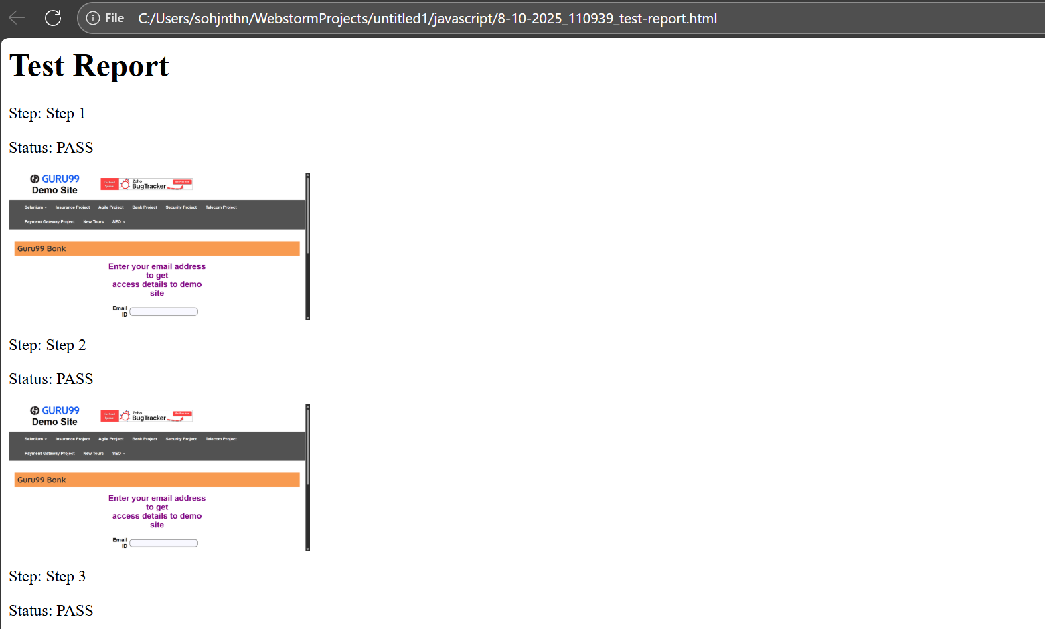

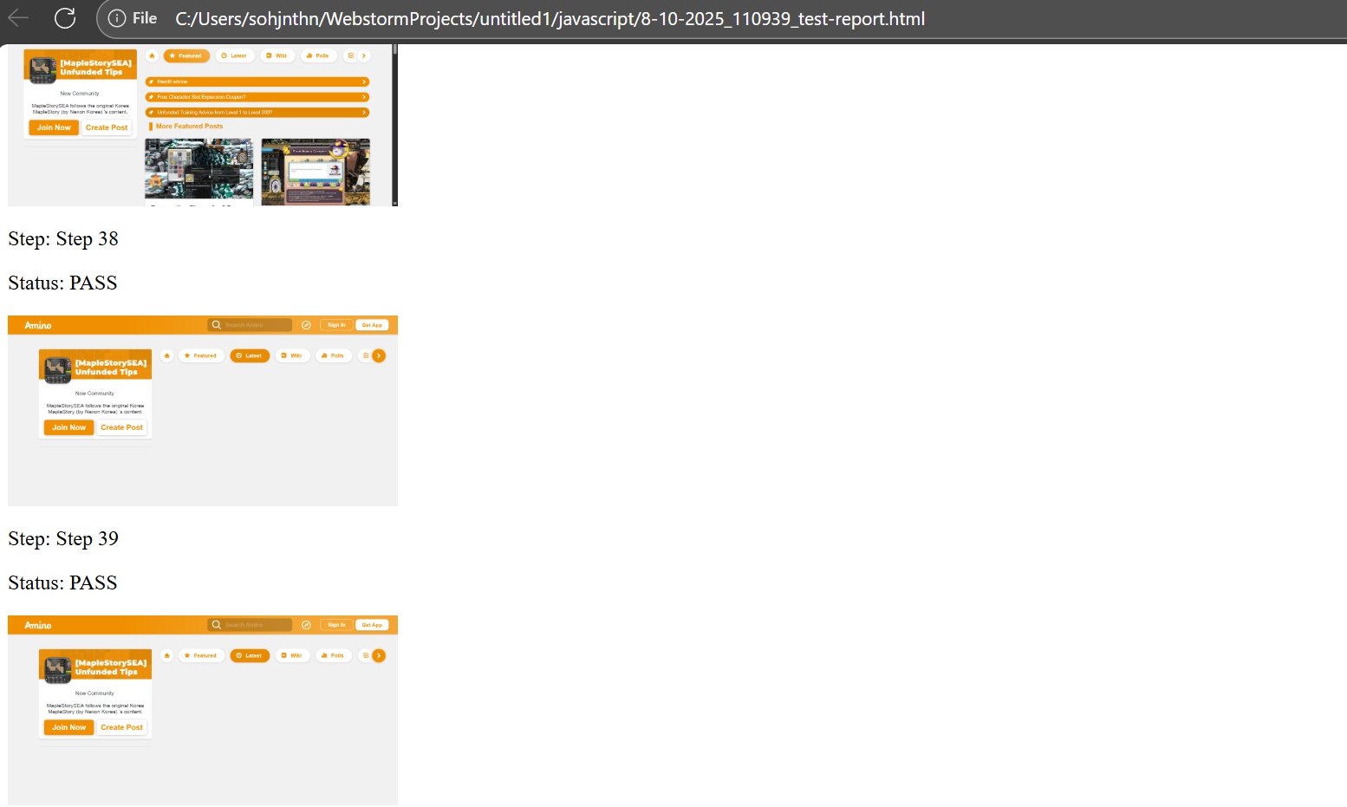

SecondGroupOfWebsites.js
const {By, Builder, Browser, Key} = require('selenium-webdriver');
const assert = require("assert");
const {writeFileSync} = require("node:fs");
const {write} = require("selenium-webdriver/io");
const test = require("node:test");
const fs = require('fs');
// const WebDriverIO = require("WebDriverIO");

let startIndex = 0
let endIndex = 5
let pdfMagicNumber = 'JVBER'
let imgMagicNumber = 'iVBOR'
let base64Code

(async function SecondGroupOfWebsites() {

async function takeTheScreenshot() {
let encodedString = await driver.takeScreenshot();
const now = new Date();
const formattedDateTime = `${now.getDate()}-${(now.getMonth() + 1).toString().padStart(2, '0')}-${now.getFullYear().toString().padStart(2, '0')}_${now.getHours().toString().padStart(2, '0')}${now.getMinutes().toString().padStart(2, '0')}${now.getSeconds().toString().padStart(2, '0')}`;
console.log(formattedDateTime);
let text1 = formattedDateTime;
let text2 = "_image.png";
await writeFileSync(text1.concat("", text2), encodedString, 'base64');
base64Code = encodedString.slice(startIndex, endIndex);
assert.strictEqual(base64Code, imgMagicNumber);
console.log("The takeTheScreenshot() function's returned text is: " + text1 + text2);
let returnString = text1 + text2;
console.log("returnString is: " + returnString);
return returnString;
}

function currentDateTime(){
const now = new Date();
const formattedDateTime = `${now.getDate()}-${(now.getMonth() + 1).toString().padStart(2, '0')}-${now.getFullYear().toString().padStart(2, '0')}_${now.getHours().toString().padStart(2, '0')}${now.getMinutes().toString().padStart(2, '0')}${now.getSeconds().toString().padStart(2, '0')}`;
return formattedDateTime;
}

let screenshotFilenameArray = [];

let i = 1;
let stepNameString = 'Step ' + i;
const testResults = [
//{ step: stepNameString, screenshot: screenshotFilenameArray[0], status: 'PASS' },
];

let driver;

driver = await new Builder().forBrowser(Browser.CHROME).build();

driver.get("https://aminoapps.com/c/maplestorysea/recent/");

let title13 = await driver.getTitle();

screenshotFilenameArray.push(await takeTheScreenshot());
console.log("length of screenshotFilenameArray is: " + screenshotFilenameArray.length);
testResults.push({step: stepNameString, screenshot: screenshotFilenameArray[i-1], status: 'PASS'});
i = i + 1;
stepNameString = 'Step ' + i;

// Unable to identify Create Post button as
// > Create Post <
// has whitespace character(s) directly after ">"; and/or directly before "<"

screenshotFilenameArray.push(await takeTheScreenshot());
console.log("length of screenshotFilenameArray is: " + screenshotFilenameArray.length);
testResults.push({step: stepNameString, screenshot: screenshotFilenameArray[i-1], status: 'PASS'});
i = i + 1;
stepNameString = 'Step ' + i;

let htmlContent = '<html><body><h1>Test Report</h1>';
testResults.forEach(result => {
htmlContent += `<div>
<p>Step: ${result.step}</p>
<p>Status: ${result.status}</p>
<img src="${result.screenshot}" alt="Screenshot" width="300">
</div>`;
});
htmlContent += '</body></html>';
fs.writeFileSync('./' + currentDateTime() + '_test-report.html', htmlContent);
console.log('Report generated: test-report.html');

// Does nothing (the fourth html report is not generated)
// return testResults;

}())

7 October 2025 11:20:16 pm run for SecondGroupOfWebsites.js-
Note that this is for an earlier run of SecondGroupOfWebsites.js (via MainWebsites.js) which generated the correct steps’ screenshot images after multiple tries (the latest html report has incorrect screenshot image(s)).
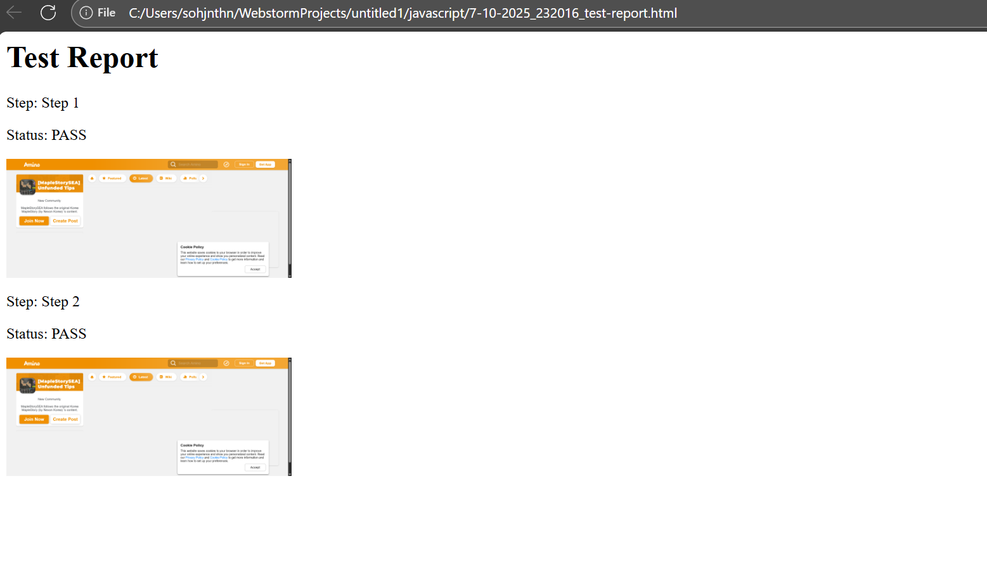

ThirdGroupOfWebsites.js
const {By, Builder, Browser, Key} = require('selenium-webdriver');
const assert = require("assert");
const {writeFileSync} = require("node:fs");
const {write} = require("selenium-webdriver/io");
const test = require("node:test");
const fs = require('fs');
// const WebDriverIO = require("WebDriverIO");

let startIndex = 0
let endIndex = 5
let pdfMagicNumber = 'JVBER'
let imgMagicNumber = 'iVBOR'
let base64Code

(async function ThirdGroupOfWebsites() {

async function takeTheScreenshot() {
let encodedString = await driver.takeScreenshot();
const now = new Date();
const formattedDateTime = `${now.getDate()}-${(now.getMonth() + 1).toString().padStart(2, '0')}-${now.getFullYear().toString().padStart(2, '0')}_${now.getHours().toString().padStart(2, '0')}${now.getMinutes().toString().padStart(2, '0')}${now.getSeconds().toString().padStart(2, '0')}`;
console.log(formattedDateTime);
let text1 = formattedDateTime;
let text2 = "_image.png";
await writeFileSync(text1.concat("", text2), encodedString, 'base64');
base64Code = encodedString.slice(startIndex, endIndex);
assert.strictEqual(base64Code, imgMagicNumber);
console.log("The takeTheScreenshot() function's returned text is: " + text1 + text2);
let returnString = text1 + text2;
console.log("returnString is: " + returnString);
return returnString;
}

function currentDateTime(){
const now = new Date();
const formattedDateTime = `${now.getDate()}-${(now.getMonth() + 1).toString().padStart(2, '0')}-${now.getFullYear().toString().padStart(2, '0')}_${now.getHours().toString().padStart(2, '0')}${now.getMinutes().toString().padStart(2, '0')}${now.getSeconds().toString().padStart(2, '0')}`;
return formattedDateTime;
}

let screenshotFilenameArray = [];

let i = 1;
let stepNameString = 'Step ' + i;
const testResults = [
//{ step: stepNameString, screenshot: screenshotFilenameArray[0], status: 'PASS' },
];

let driver;

driver = await new Builder().forBrowser(Browser.CHROME).build();

// It is not possible to reach the correct webpage without causing an error for Javascript
// So the website address needs to be manually provided
driver.get("https://aminoapps.com/c/maplestorysea/home/");

let title14 = await driver.getTitle();

screenshotFilenameArray.push(await takeTheScreenshot());
console.log("length of screenshotFilenameArray is: " + screenshotFilenameArray.length);
testResults.push({step: stepNameString, screenshot: screenshotFilenameArray[i-1], status: 'PASS'});
i = i + 1;
stepNameString = 'Step ' + i;

// We need to use By.xpath to identify that the contained text is the following
// (Only Java, and Python can identify the correct WebElement based on the index position which starts from 0 (for the firstWebElement of the WebElement List)
let latestTab = await driver.findElement(By.xpath("//*[contains(text(), 'Latest')]"));
latestTab.click();

screenshotFilenameArray.push(await takeTheScreenshot());
console.log("length of screenshotFilenameArray is: " + screenshotFilenameArray.length);
testResults.push({step: stepNameString, screenshot: screenshotFilenameArray[i-1], status: 'PASS'});
i = i + 1;
stepNameString = 'Step ' + i;

// Unable to identify Amino Home icon

screenshotFilenameArray.push(await takeTheScreenshot());
console.log("length of screenshotFilenameArray is: " + screenshotFilenameArray.length);
testResults.push({step: stepNameString, screenshot: screenshotFilenameArray[i-1], status: 'PASS'});
i = i + 1;
stepNameString = 'Step ' + i;

// Unable to identify Create Post button as
// > Create Post <
// has whitespace character(s) directly after ">"; and/or directly before "<"

screenshotFilenameArray.push(await takeTheScreenshot());
console.log("length of screenshotFilenameArray is: " + screenshotFilenameArray.length);
testResults.push({step: stepNameString, screenshot: screenshotFilenameArray[i-1], status: 'PASS'});
i = i + 1;
stepNameString = 'Step ' + i;

let htmlContent = '<html><body><h1>Test Report</h1>';
testResults.forEach(result => {
htmlContent += `<div>
<p>Step: ${result.step}</p>
<p>Status: ${result.status}</p>
<img src="${result.screenshot}" alt="Screenshot" width="300">
</div>`;
});
htmlContent += '</body></html>';
fs.writeFileSync('./' + currentDateTime() + '_test-report.html', htmlContent);
console.log('Report generated: test-report.html');

// Does nothing (the fourth html report is not generated)
// return testResults;

}())

8 October 2025 - 11:07:39 am run for ThirdGroupOfWebsites.js
